**Sales Data Analysis Report**

# ***Executive Summary:***

**We analysis data of sales to extract information and gain insights that help to make decisions and to optimize our service based on certain scope.**

## ***Scope:***

1. **Improve our strength :**

**• Which region has the highest sales value in 2023?**

**• Which category of products generate the most sales by region?**

**• Which product has the most percentage (contribution) of sales by region?**

**• Which products has the most percentage (contribution) of sales?**

1. **Promote Customer experience:**

**• Which months and days has the highest sales value?**

**• Average of discount in terms of product sales ?**

**• Do discounts negatively or positively affect sales?**

# Data Collection & Methodology:

### •Data source: Sales _data _2023_2024(xlsx file).

### •Tools Used : Excel(power query , power pivot).

### •Pre processing steps : add new columns (discount price ,COGS) ,(Create Measures) by power pivot.

# Data Analysis:

**Improve our strength :**

**• Which region has the highest sales value in 2023?**

**Findings:** **North region has the most sales value.**

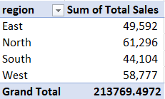

**Recommendations:**

1. **optimize Inventory (Ensure stock availability for their frequently purchased items).**
2. **Offer promotions and discount to promote sales in other regions.**
3. **Obtain customer feedback to boost sales.**

**Which category of products generate the most sales by region?**

**Findings :Electronic category in North region has the highest sales vales.**

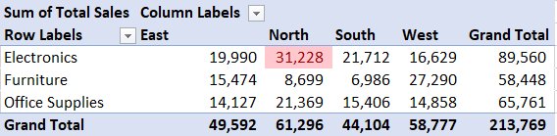

**Recommendations:**

1. **recommend electronic products for customers in this region .**
2. **promote products of Furniture category .**
3. **ensure of clarity product description .**

Which product has the most percentage (contribution) of sales by region?

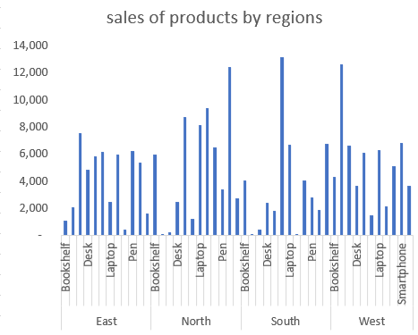Findings: Headphones product in South region has the most contribution.

**Recommendations:**

1. **Sell headphones with accessories like cases, charging cables, or Bluetooth adapters.**

**Which products has the most percentage (contribution) of sales ?**

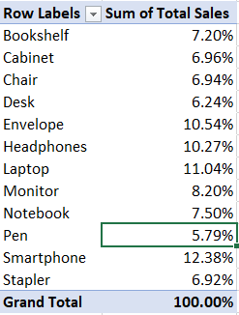**Findings:** **smart phone product has the most contribution in sales vales.**

**Recommendations:**

1. **Collaborate with local influencers to promote smart phone.**
2. **Offer accessories or extended warranties with smartphones to increase value.**
3. **Create campaigns for enhance other products sales.**

**2-Promote Customer experience:**

**Which months has the highest sales value?**

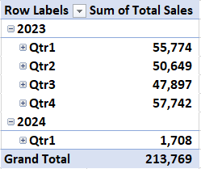**Findings: in quarter 4(last 3 month in 2023) sales value is high.**

**Recommendations:**

1. **Plan exclusive discounts and cashback offers.**
2. **Creating excellence in that period to gain a competitive advantage.**

**Average of discount in terms of product sales and how discounts negatively or positively affect sales ?**

**Findings: in the first 3 month average of discount and sales are higher than first 3 month in 2024 so discount affect sales positively.**

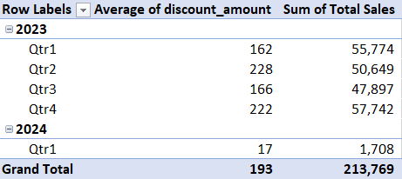

**Recommendations:**

**1-enhance the Shopping Experience by ensure discounts are clearly displayed on websites, apps, and stores.**

**2-Use past purchase data to offer personalized discounts on relevant products.** 

**“By implementing these recommendations, we aim to enhance customer satisfaction, reduce return rates, and increase profitability. We look forward to further discussions on refining our strategy.”**

**Prepared by:  
 • Data Analyst : Doha Masoud.  
 • Email:** [**dohamasoud25@gmail.com**](mailto:dohamasoud25@gmail.com) **.**